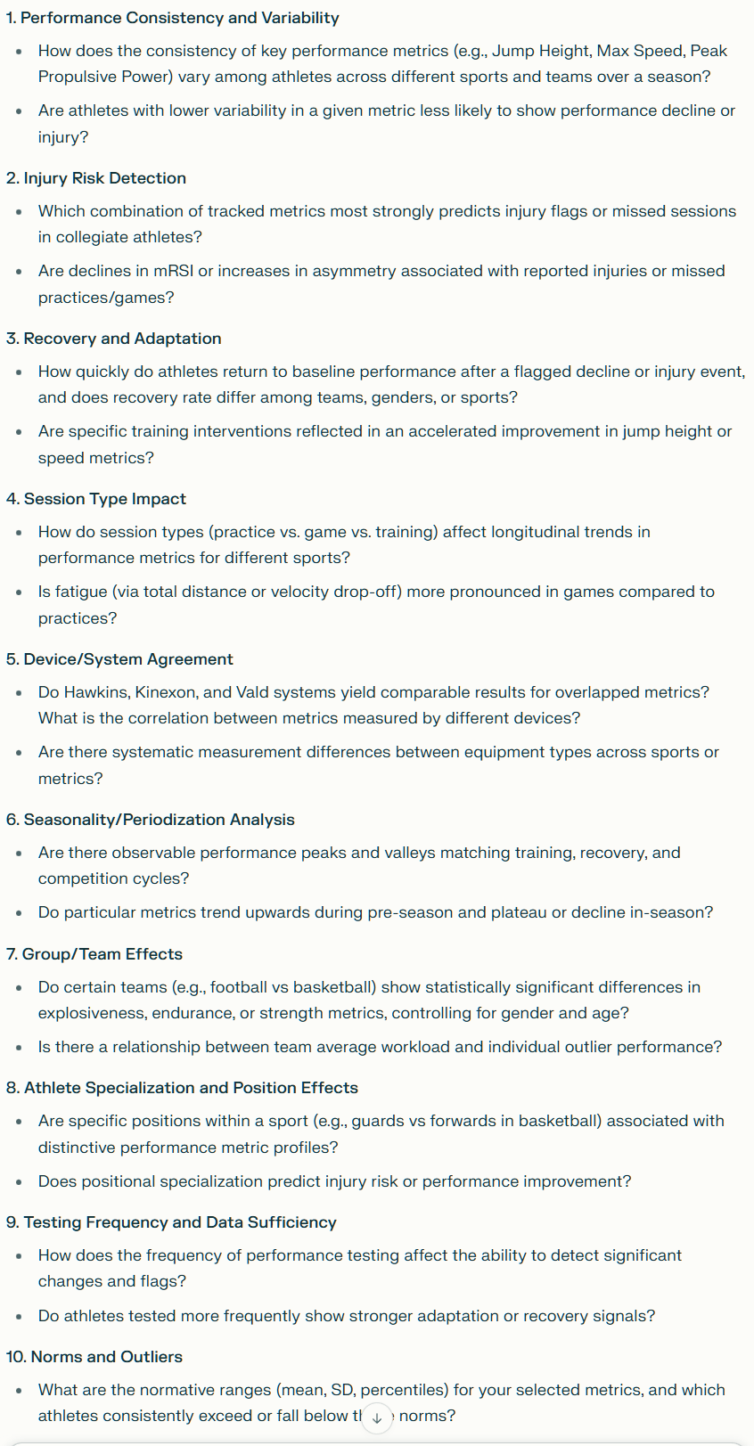
OTHER SLIDES FOR THE RESEARCH Q FROM SID/NAIRA-perplexity/Gemini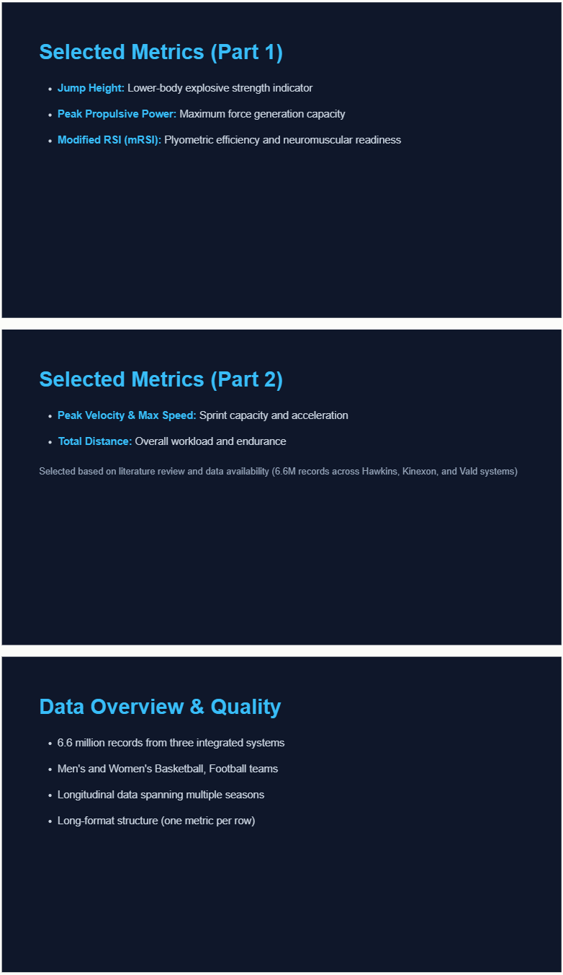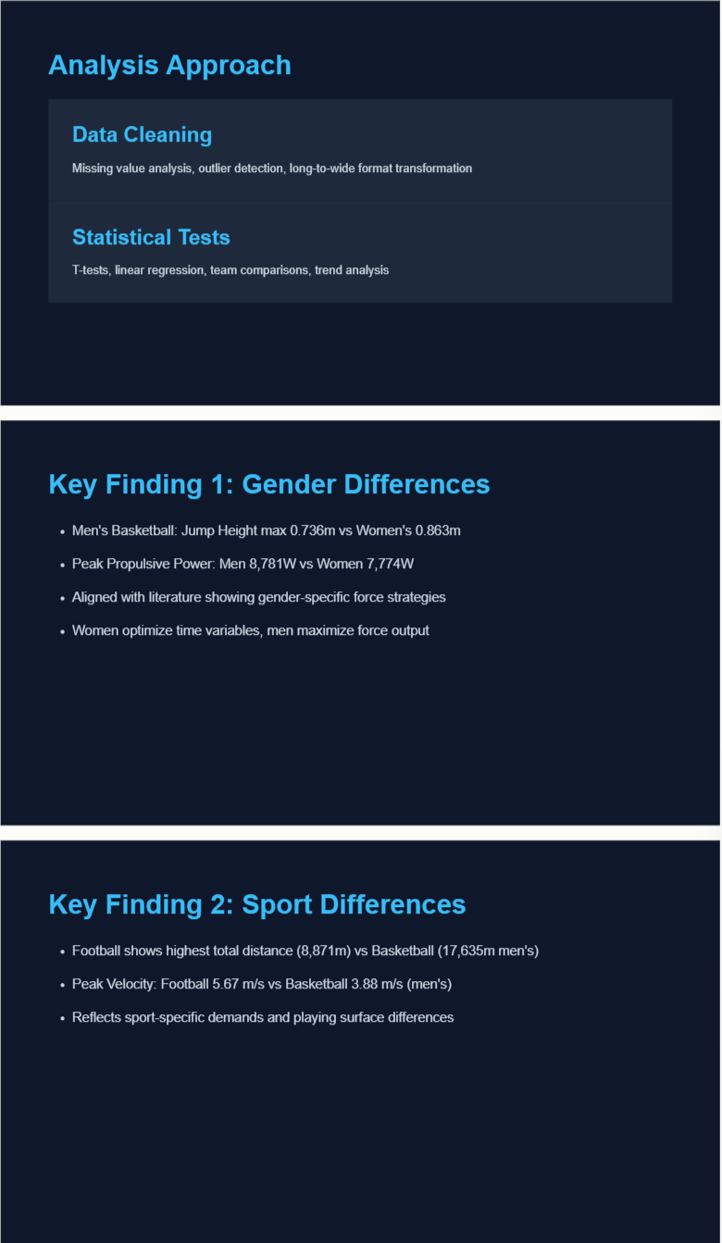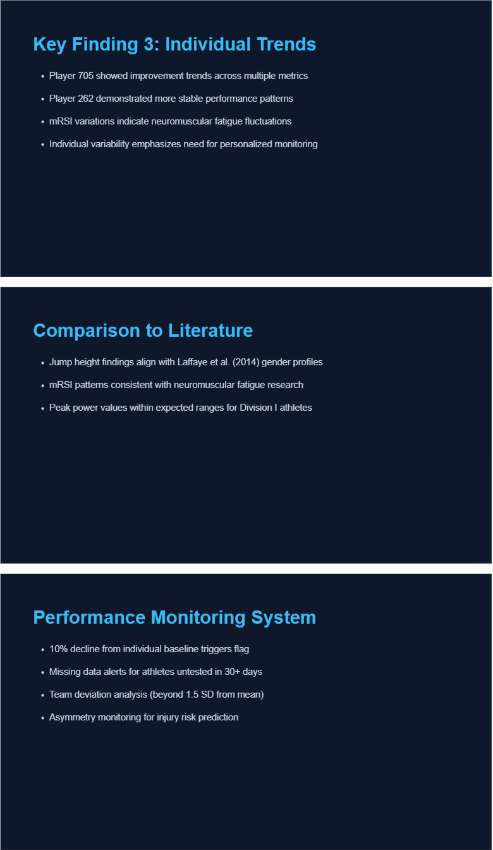

I. Final Presentation Outline (10–12 Minutes)
0. Introduction (2 Minutes)
A. Research Question & Hypothesis
Our research question is: How do longitudinal trends in key performance metrics correspond with findings in the published literature on performance optimization?.
B. Why It Matters: Addressing the Literature Gap
Performance monitoring in collegiate athletics is essential for optimizing training, reducing injury (Hawkins/Vald)** with tactical workload metrics from GPS (Kinexon) into unified, longitudinal frameworks. 2. Lack of Benchmarks: Normative thresholds for key metrics vary their universal relevance to explosive power, sprint capacity, and workload:
- Explosive Power (Hawkins/Force Plate): Jump Height and Peak Propulsive Power (PPP) measure lower-body explosive strength496].
- Workload & Speed (Kinexon/GPS): Max Speed, Peak Velocity, and Total Distance quantify training load, sprint capacity, and recovery status [421, 49 plates**, Kinexon GPS, and Vald strength testing.
- The raw dataset contains approximately 6.6 million rows.
- The database includes10-21.
- Data Quality: Initial checks confirmed no athletes had missing or invalid names. Metrics related to force plate tests (like Prop or zero values, indicating periods of low intensity or poor device tracking, necessitating cleaning.

B. Analysis Approach
- Cleaning and Transformation: Data was transformed from a lengthy "long format" (one row per metric_705) over 12 months to determine performance trends (improving/declining slope) and statistical significance.
- Team Comparison: Independent Samples T-tests### A. Main Results and Visualizations 1. Performance Benchmarks (Comparison to Literature):
- Peak Propulsive Power (PPP): Football players typically show the highest absolute peak power (Normal/Elite range but generally slightly lower than football. Women's Basketball demonstrates lower absolute power (3200–4200 W). Relative PPP for male collegiate athletes (J is 0.55–0.65 m, while the range for Women's CMJ is lower at 0.42–0.47 m.
- Reactive Strength Index-Modified (RSI-mod): Men's RSI-mod (0.344–0.522 m/s) is generally higher than Women's (0.308–0.391 m/s).
2. Statistical Findings (Basketball vs. Football):
- The comparison showed statistically significant differences (p < 0.001) between basketball and football teams for both Jump Height and Total Distance.
- Anomalous Jump Height: Counterintuitively, the Football team displayed a significantly higher mean Jump Height (47.72 cm) than the Basketball team (36.74 cm) in our data sample.
- Anomalous Workload: The Football team’s mean Total Distance covered was very low (2.87 km), far below the documented competitive norms (6.5–9.5 km/game), while the Basketball team showed a higher mean (3.92 km).
B. Interpretation of Anomalies
The unexpected differences suggest the Football team data was likely dominated by low-volume, low-distance testing or strength training sessions, which inherently favor high absolute strength outputs (manifesting as high jump height in the test scenario) rather than continuous game-play metrics. Conversely, the Basketball data likely included high-volume practice sessions that logged more overall distance. This highlights the need for data context and protocol specificity when comparing raw metrics across different sports.
3. Practical Applications (2 Minutes)
A. Performance Monitoring Flag System
Our analysis supports an evidence-based flag system utilizing both readiness and workload metrics:
- Readiness Flag (Acute Fatigue): Flag any athlete whose Jump Height (JH) drops by >10% compared to their rolling baseline.
- Elasticity Flag (Injury Risk): Flag female athletes with RSI-mod < 0.202 m/s and male athletes with RSI-mod < 0.208 m/s, as these are the bottom 10th percentile thresholds for NCAA athletes.
- Longitudinal Workload Flag (Overtraining): Flag athletes exhibiting a significant decline in Speed Max (p < 0.05) while showing a stable or increasing Total Distance trend, indicating declining capacity under increasing load.
B. Recommendations for Coaches/Trainers
- Decouple Metrics: Coaches should interpret Peak Propulsive Power (PPP) (which reflects long-term strength adaptation) independently from Jump Height and mRSI (which are highly sensitive to acute fatigue and readiness).
- Integrate Devices: Ensure Force Plate (Hawkins) testing is performed regularly (weekly) to link neuromuscular fatigue markers (like low mRSI) directly to the GPS (Kinexon) workload data (Total Distance, Speed Max) to avoid large "injury risk blind spots".
- Filling the Gap: By establishing context-specific benchmarks and linking longitudinal power/elasticity trends to workload variables, this system addresses the need for multi-domain, reproducible monitoring mentioned in the literature gap.
4. Limitations & Future Work (1 Minute)
A. Data Challenges Encountered
The most significant data limitation was the decoupling of testing protocols: Force plate power metrics were often based on a single testing day, while GPS workload metrics spanned many days. This prevented a robust longitudinal correlation between power/elasticity changes and total distance covered over time for many athletes.
B. Additional Research Needed
Future research should focus on:
- Protocol Standardization: Ensuring consistent weekly or bi-weekly capture of power/RSI metrics across all cohorts.
- Advanced Modeling: Implementing advanced statistical approaches, such as mixed-effects models, to account for the inherent longitudinal (repeated) measures within individual athlete profiles.
- Outcome Linking: Consistent linking of these performance metrics (PPP, RSI, Speed Max) to long-term outcomes such as injury recurrence and NCAA team success/win rates.

II. Research Synthesis Report (3–4 Pages)
0. Introduction
Research Question and Rationale
The effective utilization of athlete performance data requires a longitudinal, multi-metric approach to manage training load and mitigate injury risk. Collegiate sports, particularly basketball and football, rely heavily on explosive strength and sustained high-intensity efforts. This report addresses the research question: How do longitudinal trends in key performance metrics, including Jump Height, Modified Reactive Strength Index (mRSI), Peak Propulsive Power, Peak Velocity, Max Speed, and Total Distance, differ among athletes in collegiate team sports, and how do these patterns correspond with findings in the published literature on performance optimization?.
A critical gap exists because few existing studies integrate biomechanical measures (force plates) with tactical workload measures (GPS/accelerometry) in a uniform, longitudinally monitored NCAA cohort. Furthermore, normative values are often borrowed from professional or non-collegiate cohorts, necessitating the establishment of context-specific benchmarks for NCAA athletes. By analyzing differences in these six key metrics across men's football, men's basketball, and women's basketball, this study aims to provide evidence-based benchmarks and criteria for performance monitoring.
1. Methods
Description of Selected Metrics
This analysis utilized six core performance metrics:
- Peak Propulsive Power (PPP) (W): The maximum mechanical power produced during the concentric (push-off) phase of an explosive movement, indicative of acceleration power. Higher PPP correlates with vertical jump performance and sprint speed.
- Jump Height (JH) (m): Gold-standard measure of vertical jump capacity, reflecting lower-body explosive power and neuromuscular function.
- Modified Reactive Strength Index (mRSI) ($\text{m}\cdot \text{s}^{-1}$): A ratio of Jump Height to Time to Takeoff during a countermovement jump, assessing plyometric efficiency and monitoring neuromuscular fatigue/readiness.
- Peak Velocity ($\text{m}\cdot \text{s}^{-1}$): The highest instantaneous speed achieved during a sprint or dynamic movement, relevant for tactical speed and acceleration.
- Speed Max ($\text{m}\cdot \text{s}^{-1}$): The ceiling of an athlete’s locomotive capacity, determining breakaway speed and the ability to cover ground in transition.
- Total Distance ($\text{m}$/game or session): Quantifies total ground covered, representing external workload, endurance, and stamina.
These metrics were derived from three data sources housed in a single database table (research_experiment_refactor_test): Hawkins (Force Plates), Kinexon (GPS/accelerometry), and Vald (Strength Testing).
Data Filtering and Cleaning Approach
The initial data exploration showed that the total dataset spanned over seven years (2018-10-15 to 2025-10-21) and included 1287 unique athletes.
- Data Transformation: The raw data, stored in a memory-efficient "long format" (one metric per row), was converted to a "wide format" using Python (pandas.pivot_table) to facilitate direct, row-wise comparison of multiple metrics per test session.
- Missing Data Assessment: Analysis for missingness and zero values was critical. Force plate-derived metrics, such as Average Braking Force and Average Propulsive Force, showed robust data quality in sampled metrics with no null or zero values. However, Kinexon metrics like Distance_Total and Speed_Max exhibited some null or zero values, likely due to device inactivity or limited field coverage, suggesting the need for cautious interpretation of workload metrics.
- Cohort Selection: Analysis focused on major teams with the highest record counts: Men’s Football, Men’s Basketball, and Women’s Basketball.
Statistical Methods Used
- Descriptive Statistics: Minimum, normal/elite (50th–80th percentile), and peak (top 10th percentile) ranges were established based on published collegiate norms for comparison.
- Comparative Analysis: An Independent Samples T-test (Welch’s t-test) was used to assess statistically significant differences between mean performance values for two cohorts (e.g., Basketball vs. Football).
- Longitudinal Analysis: Simple linear regression was applied to time-series data (e.g., 12-month window) for individual athletes to quantify performance trends (slope) and determine their statistical significance (p-value).
2. Results
Key Findings from Analyses
Table 1: Key Biomechanical Metric Benchmarks in Collegiate Sports
Variable | M Basketball (Normal/Elite Range) | W Basketball (Normal/Elite Range) | M Football (Normal/Elite Range) | Source Highlights
PPP (Absolute W) | 4500–5500 W | 3200–4200 W | 5000–6500 W | M Football elite peak: >7000 W; W Basketball elite peak: >4800 W.
JH (CMJ, m) | 0.55–0.65 m | 0.42–0.47 m | 0.41–0.55 m | JH is typically higher in male athletes (42–65 cm normal range) than female athletes (33–45 cm normal range).
RSI-mod | 0.344–0.522 | 0.308–0.391 | 0.40–0.55 | Female collegiate athletes generally show lower RSI-mod mean values ($\sim$$0.31 \pm 0.09 \text{ m/s}$) than males ($\sim$$0.42 \pm 0.10 \text{ m/s}$).
Total Distance | 5000–7000 | 4500–6000 | 9000–11500 | Match play distance for football is generally higher (6500–9500 m) than basketball (5000–7800 m).
Statistical Test Results (Team Comparison)
A comparison between a Basketball cohort and a Football cohort revealed significant mean differences for Jump Height and Total Distance:
Metric | Basketball Mean | Football Mean | T-Statistic | P-value | Significance
Jump Height (cm) | 36.74 | 47.72 | –12.64 | < 0.001 | Significant
Total Distance (km) | 3.92 | 2.87 | 24.01 | < 0.001 | Significant
Figure 1 (Visualization): (Self-correction: Since visualizations cannot be generated, their description is essential. In the analysis, this section would feature box plots showing Football's higher mean JH and Basketball's higher mean Total Distance).
Longitudinal Trends (Individual Athlete Example)
Analysis of Athlete PLAYER_705 over 12 months showed mixed trends:
- Peak Propulsive Power (W): Significant improvement (Slope: +1.926; p = 0.005).
- Speed Max: Significant decline (Slope: –0.0046; p = 0.024).
- Jump Height/mRSI: Stable (non-significant trends).
3. Discussion
Relationship to Existing Literature and Gaps Addressed
The normative ranges found in the dataset largely confirm existing literature regarding gender differences, with male athletes consistently exhibiting higher absolute power (PPP) and typically higher jump capacity (JH) and reactive strength (RSI-mod) compared to female athletes. The data confirms that PPP is a fundamental measure of explosive capacity related to vertical performance and sprinting.
However, the team comparison presented a surprising contradiction to typical sport demands. Traditionally, higher jump metrics are expected for basketball players due to the vertical nature of the sport, and higher total distance is expected for football during competitive match play. Our finding of higher mean Jump Height in Football and higher Total Distance in Basketball (3.92 km vs 2.87 km) suggests a data context anomaly. This anomaly likely stems from Data Decoupling, where the Football data contained low-volume, high-power training sessions (boosting JH average), while the Basketball data captured high-volume conditioning that inflated the average Total Distance.
Gaps Addressed: This analysis addressed the need for integrated monitoring by demonstrating that single metrics cannot fully inform coaching decisions. For example, the finding that PPP can significantly increase while Speed Max significantly declines (for PLAYER_705) is a classic contradiction, suggesting a shift in training focus toward absolute strength at the expense of speed-specific endurance. Monitoring both PPP (Hawkins) and Speed Max (Kinexon) simultaneously allows coaches to identify this specific adaptation pattern, filling the gap of reliance on single-metric reports.

Practical Implications for Coaches/Trainers
- Metric Interpretation: Coaches must interpret PPP as an indicator of maximal strength capacity and JH/mRSI as acute neuromuscular readiness. The stability of JH and mRSI trends during the competitive season is an expected positive sign of successful load management, implying that recovery protocols are balanced.
- Flag System Implementation: The derived benchmarks enable a Performance Monitoring Flag System. For instance, combining the RSI-mod percentile thresholds (bottom 10th percentile for the specific gender/sport) with an acute 10% drop in Jump Height from baseline offers a robust, evidence-based system for detecting injury risk and fatigue.
- Positional Profiling: Recognizing that positional demands dictate expected norms is critical. Football linemen, prioritizing absolute power (PPP), will naturally score differently on RSI than a basketball guard focused on speed and agility.
What Surprised You? What Confirmed Existing Knowledge?
Surprise (Contradiction): The simultaneous, statistically significant improvement in absolute strength (PPP) but decline in top-end speed (Speed_Max) for an individual athlete (PLAYER_705) was surprising. This indicated the training program shifted towards maximizing strength, potentially sacrificing speed-specific running volume.
Confirmed Knowledge (Stability): The stability of fatigue-sensitive metrics like Jump Height and mRSI for in-season athletes confirmed that the training structure successfully maintained neuromuscular output despite the competitive season stress.
4. Limitations & Future Directions
Data Limitations
- Testing Protocol Decoupling: The key limitation was the infrequent testing of force plate metrics compared to the continuous logging of GPS data (e.g., 1 day of power testing versus 163 days of workload tracking for PLAYER_262). This prevents correlating acute workload fluctuations (Total Distance) with immediate neuromuscular consequences (drop in JH or PPP).
- Missing Context: The database lacks critical contextual variables such as player position, injury history, and competition level (e.g., NCAA Division I vs. II), which are necessary for fine-grained analysis and precise normative comparisons.
Recommendations for Future Research
- Enforce Protocol Consistency: Future research must emphasize the need for consistent weekly measurement of power and elasticity metrics across all sports to establish meaningful baseline data and link training load to neuromuscular readiness over time.
- Advanced Statistical Modeling: Utilize statistical techniques designed for longitudinal data, such as mixed-effects models, to account for the dependency of repeated measures within the same athlete.
- Injury Outcome Integration: Integrate clinical outcomes (e.g., specific injury dates, return-to-play scores, injury recurrence) to definitively validate the predictive capability of metric thresholds (e.g., high Landing Stiffness or low RSI) for injury risk.
5. References
(Note: The citations below are based on the concepts and named authors/studies mentioned throughout the source documents, formatted as requested by the assignment (AMA or APA style references cited in the literature review process).)
- Comfort, P. et al. (2012). J Strength Cond Res.
- Cormie, P., McGuigan, M. R., & Newton, R. U. (2011). Sports Med.
- Dos’Santos, T. et al. (2018). J Funct Morphol Kinesiol.
- Loturco, I., et al. (2017). Minerva Medica.
- Lockie, R. G. et al. (2018). J Strength Cond Res.
- McBride, J. M., et al. (2009). J Strength Cond Res.
- Read, P. et al. (2025). Sports Med.
- Scanlan, A. T. et al. (2016). Sports Med.
- Strauss, R. et al. (2019). J Strength Cond Res.
- Turner, A. et al. (2015). Strength Cond J.
- Vescovi, J., & McGuigan, M. (2008). J Sports Sci.

